iPad User Guide

# Connecting the iPad to the Romibo

First, turn on the robot by toggling the On/Off switch on the back of the robot to the On position

Next turn on the iPad by pressing the power button on the upper right edge.

## step 1: Connecting with Settings

Tap the Settings button

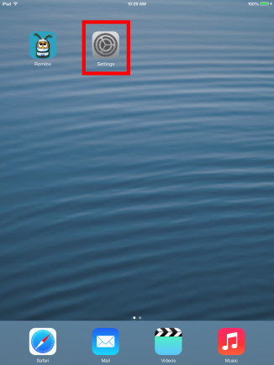

Along the left column, tap the line that says WiFi

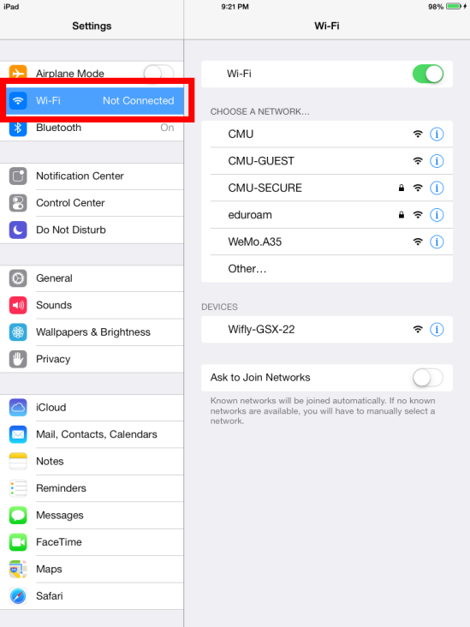

On the right column, look for the “Devices” heading. Underneath it will be a line that says “Wifly-GSX-22” – this is the robot’s network. If you don’t see the “Devices” heading or the Wifly line, try changing the robot’s batteries and turning it on again. If that doesn’t help, contact one of the developers.

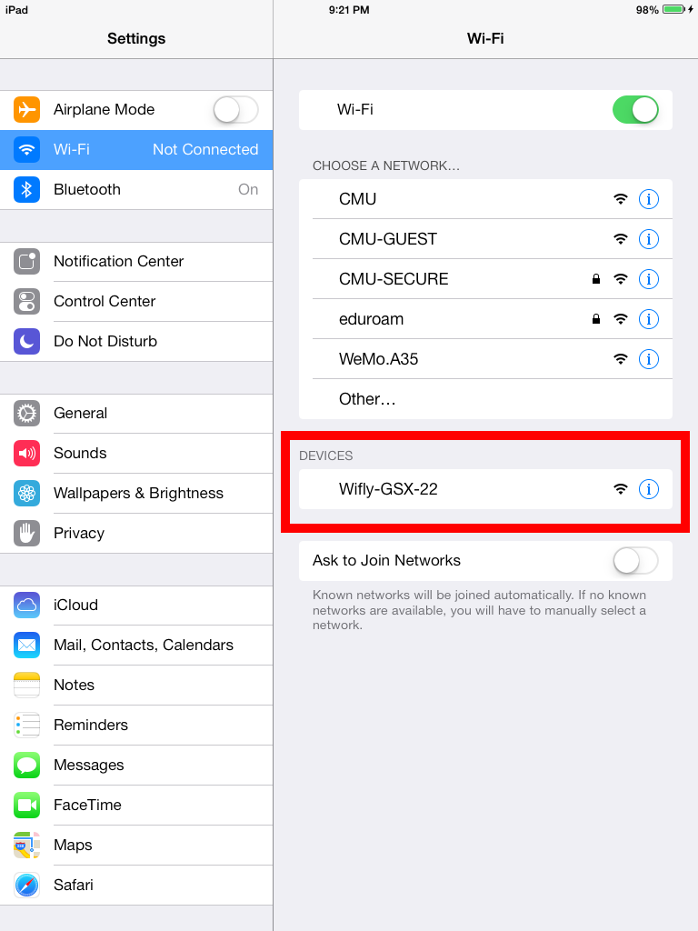

Tap the text “Wifly-GSX-22.” It will pop up a message to let you know that the network isn’t connected to the internet – click “Join Anyway”

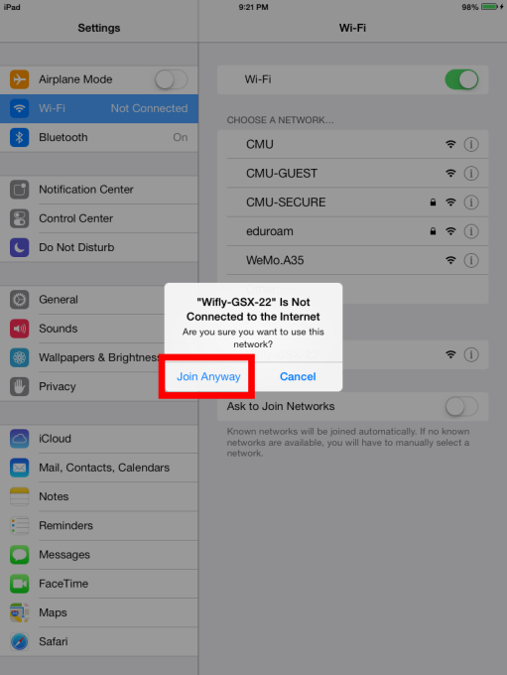

The Wifly line will jump to the top of the screen and get a blue checkmark.

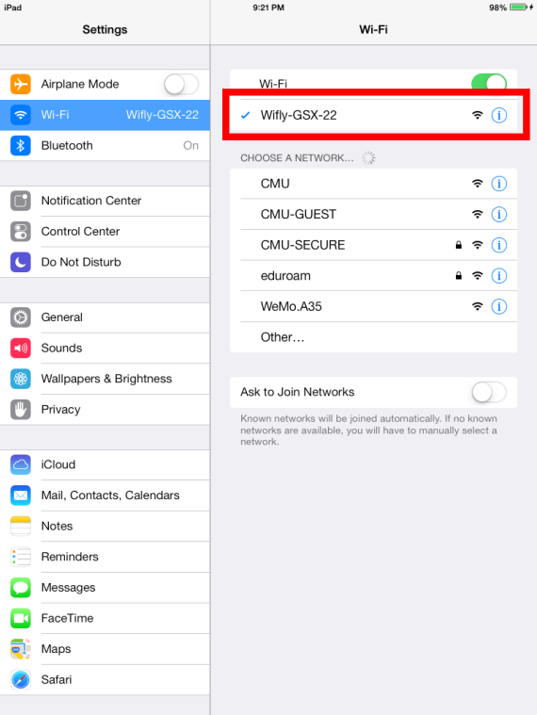

Tap the “Wifly-GSX-22” text again to see the connection details. The IP Address and Subnet Mask boxes will be empty – the iPad and the robot have to talk to each other for a minute to figure out what goes here.

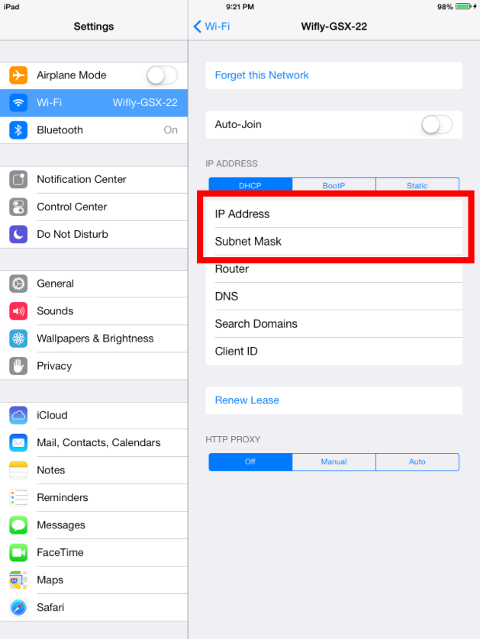

To see if the connection has been made, you have to refresh this details screen. To refresh, click the blue Wi-Fi arrow at the top of the right column.

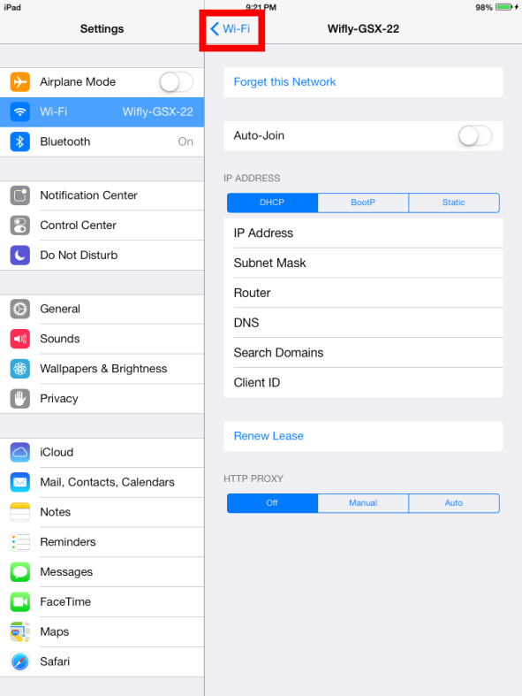

This takes you back to the list of networks we saw earlier. Click the “Wifly-GSX-22” line to view the details screen again.

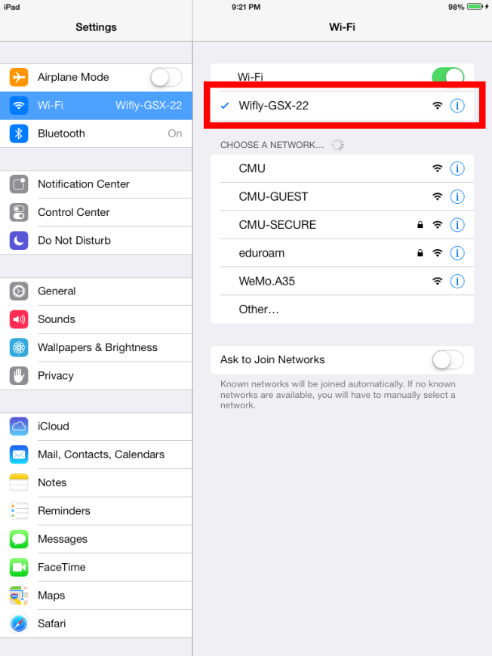

You might have to go back and forth between the details page and the list of networks a few times before the robot and the iPad are connected. When everything’s ready to go, the IP Address and Subnet Mask boxes will have numbers in them. (Don’t worry about what the exact numbers are, just make sure the boxes aren’t empty.)

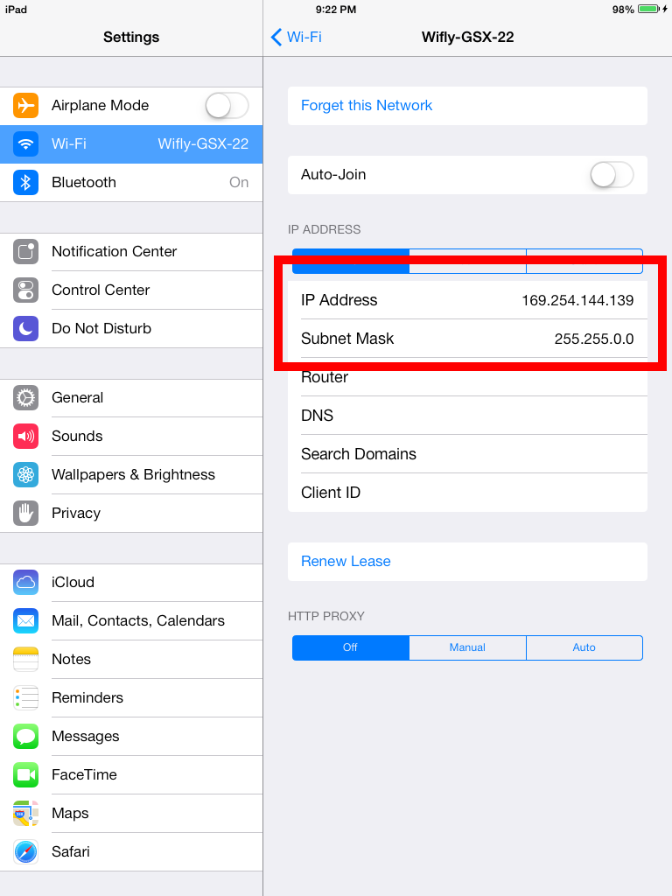

To close Settings, press the Home button at the bottom of the iPad – it’s the physical button shaped like a circle with a picture of a rounded square in the center.

## step 2: Connecting with the Romibo App

Tap the Romibo application button.

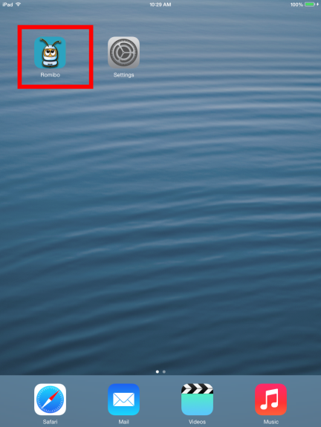

In the upper left, tap the Gear button to open the Romibo connection buttons. Notice how next to the gear button it says “Not connected”

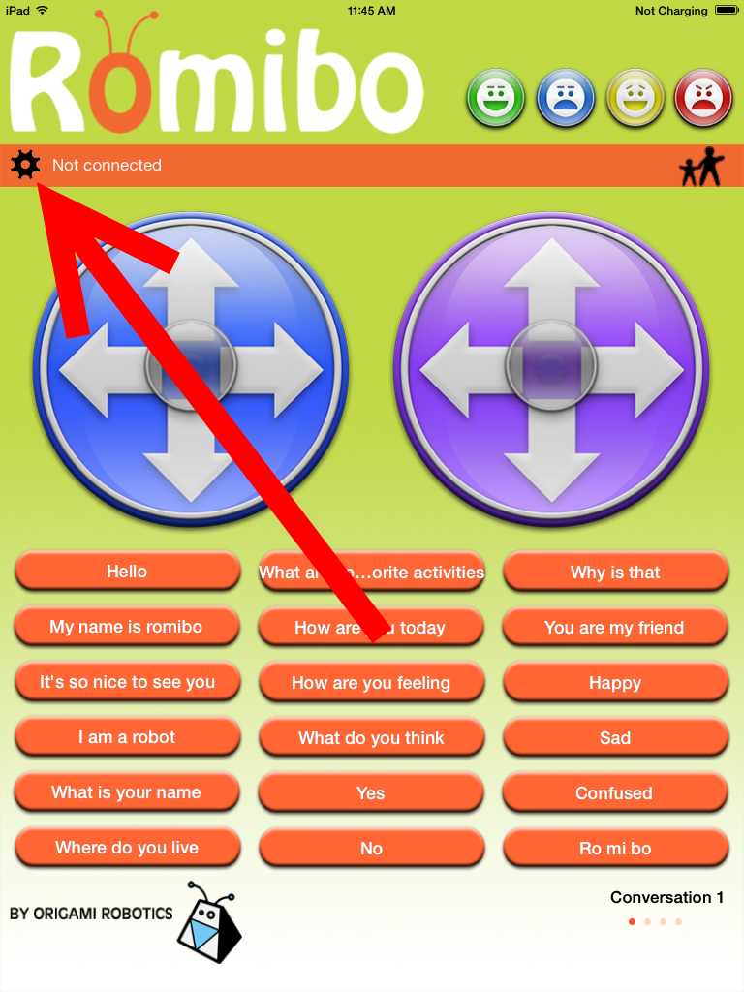

Tap the “Connect to Romibo” text.

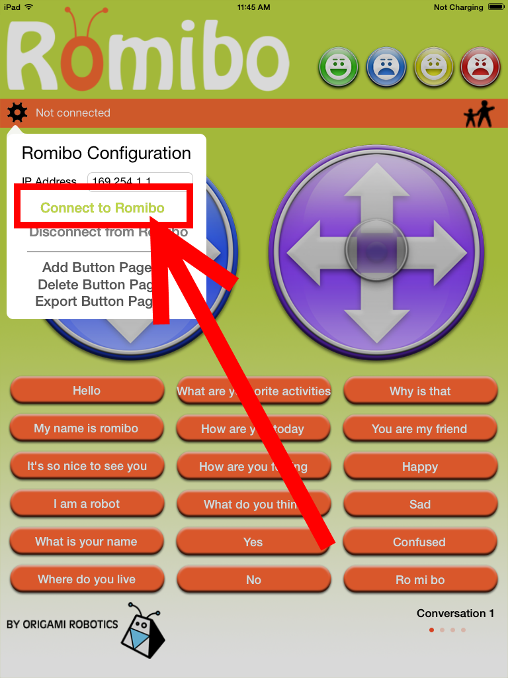

The dialog box will disappear and the text next to the gear button will say “Connected”

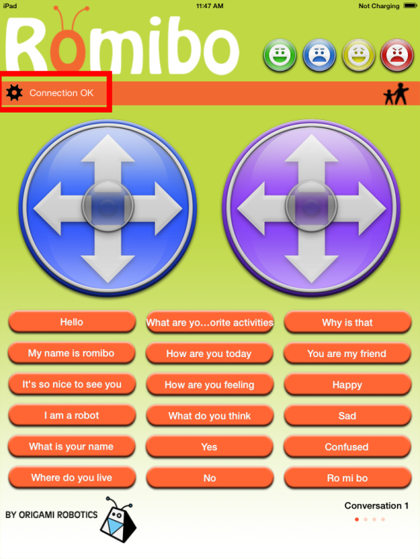

Now the robot is connected and ready to control.

# Troubleshooting

## The robot says connected but isn’t responding to the ipad

First, follow the instructions in Connecting with Settings (page 1) to make sure the details page for the WiFly-GSX-22 network has numbers in the IP Address and Subnet Mask boxes.

If that doesn’t help, disconnect and reconnect the Romibo. To do this, first tap the gear button in the upper left.

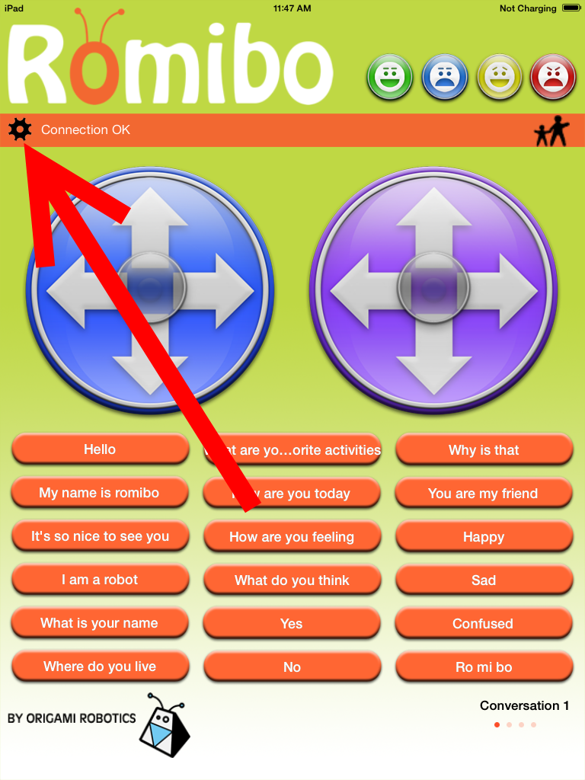

Next tap “Disconnect from Romibo”

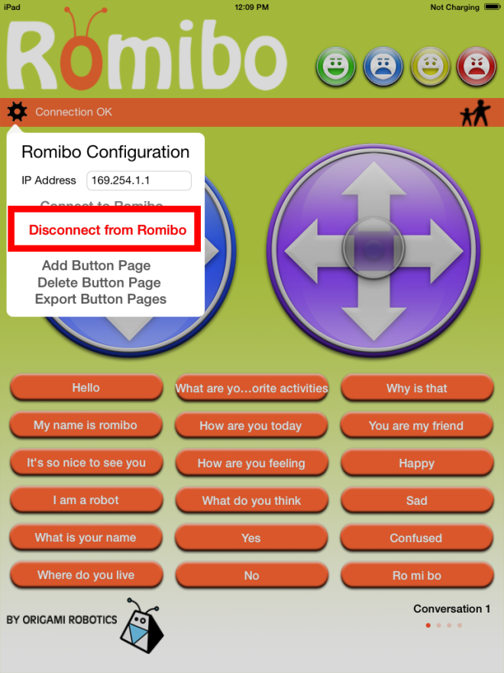

The dialog box will disappear the text “Not Connected” will be next to the gear button. Now click the gear button again.

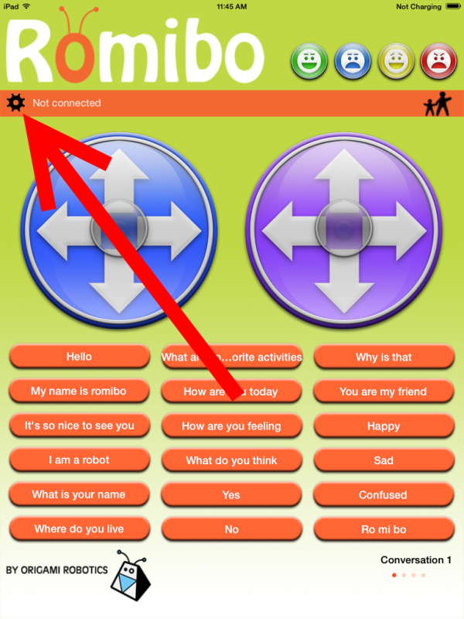

Tap the “Connect to Romibo” text.

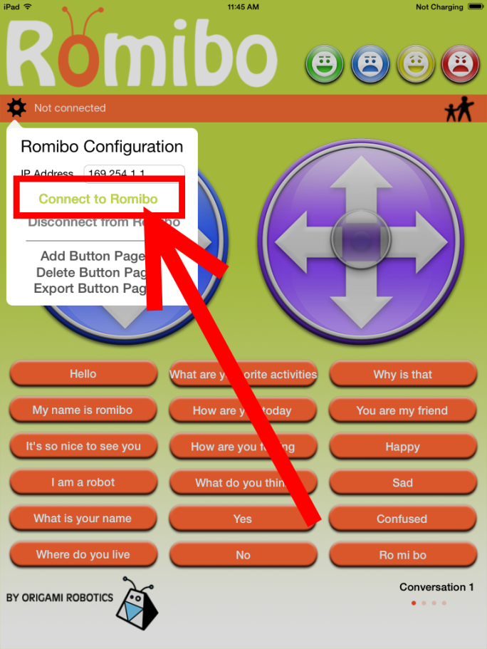

The dialog box will disappear and the text next to the gear button will say “Connected”